Directions: Eastbound
  - Start: Intersection of NC 268 and Joe Layne Mill Road
End: Intersection of Old Rockford Road and Double Creek Road

Route Summary
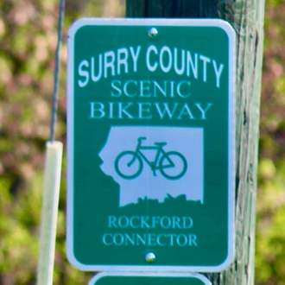
Total Distance: 12.5 Miles
Max Elevation: 1,132 Feet
Min Elevation: 823 Feet
Elevation Gain: 853 Feet
Max % Slope: 7.9%

Difficulty: Intermediate

Directions |  | Total Miles
Start | Corner of NC-268 and Joe Layne Mill Road  Dobson – Elkin Loop
Head East on NC-268 | 0.7 Miles |  | 4.4
Turn Right | West Mount Herman Church Road
Follow W Mt Herman Church Rd | 1.8 Miles |  | 8.3
Turn Left | US-601
Follow US-601 | 1.1 Miles |  | 9.5
Turn Right | Jenkinstown Road
Follow Jenkinstown Rd | 1.7 Miles |  | 12.6
Turn Right | Buck Ford Road
Follow Buck Ford Rd | 2.3 Miles |  | 13.9
Turn Right | Rockford Road |  | 16.0
Follow Rockford Rd | 1.6 Miles  Enter Historic Rockford Village
Turn Left | Old Rockford Road
Follow Old Rockford Rd | 3.3 Miles |  | 12.5
End | Corner of Old Rockford Road and Double Creek Road  Connect to Mount Airy – Pilot Mountain Loop

